These scripts are part of the lecture materials for my courses on reactor physics at Technical University of Munich. 2011 – 2016. The software comes as is, only for educational purposes and no warranties. © Dr.Sdl

There are a number of ways to represent cross sections of heavy nuclei in the resonance region. To date the Reich-Moore formalism has become a kind of standard. You can read about it in the ENDF manual (<https://www.bnl.gov/isd/documents/70393.pdf>) or at the following website: <http://t2.lanl.gov/nis/endf/rm.html>. The Reich-Moore approach comes from R-Matrix scattering theory. For those interested in the way how the measurement data is converted into this format a good starting point is the SAMMY code: Updated Users' Guide for SAMMY (<http://info.ornl.gov/sites/publications/files/Pub13056.pdf>). For those interested in the quantum mechanical details of the R-matrix theory, take a look at: The R-matrix theory (<https://arxiv.org/abs/1001.0678>)

The Reich-Moore equations can be written in the following form:

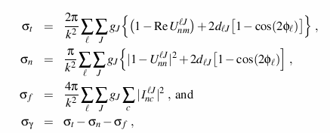

where the *I* symbol stands for an element of the inverse of the complex R-matrix, and

RM Equations 2

The elements of the complex R-matrix are given by

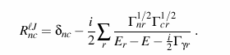

In these equations, "c" stands for the fission channel (two are allowed), "r" indexes the resonances belonging to a particular spin sequence *l,J*, and the other symbols have the same meanings as for the Single-level Breit-Wigner representation.

When fission is not present, the R matrix reduces to a simple R function, and the matrix inversion normally required to get the script-I quantities reduces to a simple inversion of a complex value.

As is the MLBW case, the summation over *J* runs over the range

RM Equations 4

The term *d* of *lJ* in the expressions for the total and elastic cross sections is used to account for the possibility of an additional contribution to the potential scattering cross section from the second channel spin. It is unity if there is a second J value equal to J, and zero otherwise. This is just a slightly different approach for making the correction discussed in connection with the MLBW method.

The following quantities are defined for the Reich-Moore representation:

**SPI**

spin *I* of the target nucleus.

**AP**

scattering radius in units of 10-12 cm.

**NLS**

number of l values (neutron orbital angular momentum) in this energy region. A set of resonances is given for each l.

**NLSC**

number of *l* values that must be used to converge the calculation with repsect to the incident *l* value in order to obtain accurate elastic angular distributions.

**AWRI**

ratio of the mass of a praticular isotope to that of a neutron.

**APL**

the *l*-dependent scattering radius. If zero, use APL=AP.

**L**

value of l.

**NRS**

number of resolved resonances for the current l value. (NRS<=600)

**ER**

resonance energy (in the laboratory system).

**AJ**

floating-point value for J (the total angular momentum of the resonance).

**GN**

neutron width evaluated at the resonance energy ER.

**GG**

radiation width.

**GFA,GFB**

partial fission widths.